“Peers Unite”

SRS Document

Here is a Social Media website to connect people from all over the world.

This application is used to search people and learn about them and also to register your account with the “Peers-Unite” platform or to delete your account.

The Below Screen offers you a choice what you want to do:

1. Create new account
2. Login to an existing account

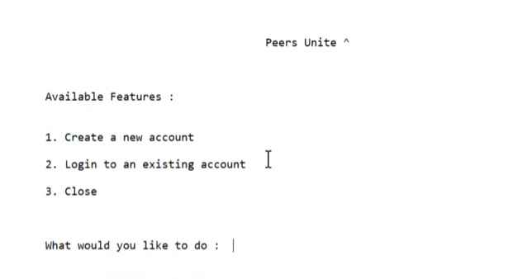

Chosen option 1

Option 1 will give you opportunity to create your account and connect your-self with “Peers-Unite”.

Fields:

>- Create a username: Text Box is alpha-numeric; this field can accept up to 30 characters.

>- Enter your name: Text Box Accepts Only Alpha characters, this field can accept up to20 characters.

>- Enter your Age: Text Box Accepts Only numeric values, this field can accept up to 2 characters.

>- Enter your email id: Text Box is alpha-numeric; this field can accept up to 20 characters.

>- Create a password: Text Box Accepts Only numeric values, this field ca accepts up to 8 characters.

>- Gender: Text Box accepts only one Alpha Character (M or F or Other).

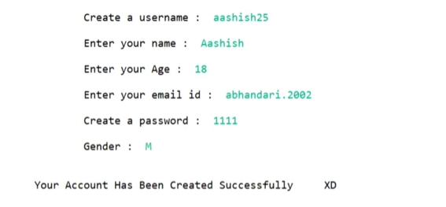

Chosen option2:

Option 2 will allow you to login to your account if you’ve already registered with “peers-unite”.

Fields:

>- Enter your username: Text Box is alpha-numeric; this field can accept up to 30 characters.

>- Enter your password: Text Box Accepts Only numeric values, this field ca accepts up to 8 characters.

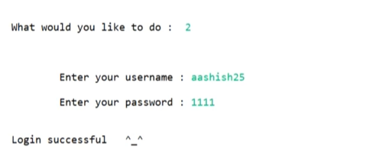

After logging successfully, it will give some other options:

1. Add more details
2. Search an account
3. Delete my account
4. Logout

Choosing option “Add more details”

Add more details will consist of the following fields:

>- Phone Number: Text Box Accepts Only numeric values, this field ca accepts up to 10 characters.

>- State: Text Box Accepts Only Alpha characters, this field can accept up to 15 characters.

>- BIO: Text Box is alpha-numeric; this field can accept up to 60 characters.

>- image location: Text Box to give the location of image from PC.

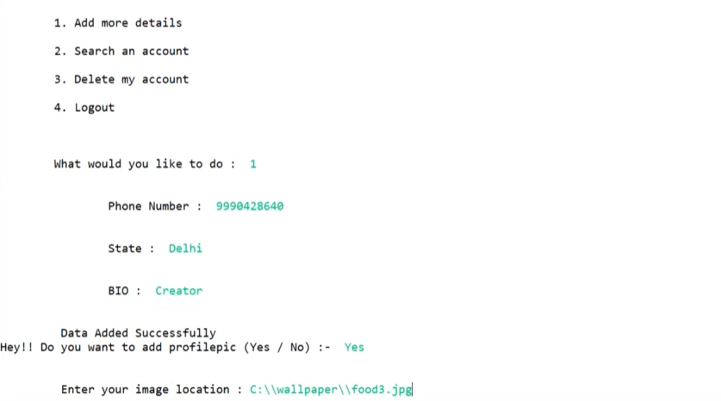

Choosing option “Search an account” Will give you opportunity to search for people already registered with “Peers-Unite”.

Search an account consist of the following fields:

>- Enter the username: Text Box is alpha-numeric, this field can accept up to 30 characters.

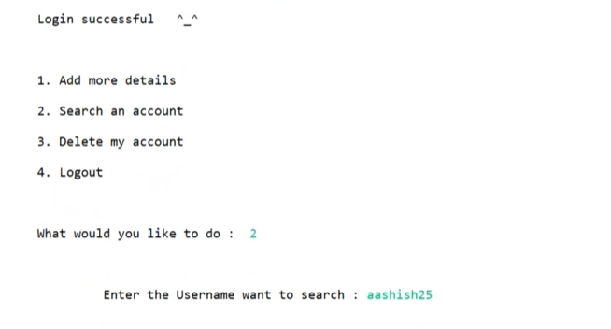

Choosing option “Delete an account” Will give you opportunity to delete your account which is registered with “Peers-Unite”.

Delete an account consist of the following fields:

>- Enter the username: Text Box is alpha-numeric; this field can accept up to 30 characters.

Choosing option “Logout an account” Will give you opportunity to logout from your account in “Peers-Unite”.